Honeywell Xenon Barcode Scanner Programming Chart

The following barcodes program the Xenon scanner’s Pre-Fix and Post-Fix characters as well as the terminator.

Note: After scanning the Programming code return the scanner to the base unit and wait for the Scanner to reconnect with the base after programming you will hear tones and flashing lights,

This reconnection is normally done within 20 Seconds

After programming the device will return the content of the Barcode with a “\” in front of the Barcode Data and a “\” after the data. The codes below will provide a terminator of <CRLF> AKA Enter, <TAB> or no terminator.

Format \BARCODEDATA\ <CR LF>

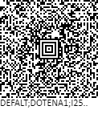

Format \BARCODEDATA\ <TAB>

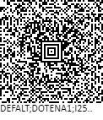

Format \BARCODEDATA\ “No Terminator”

